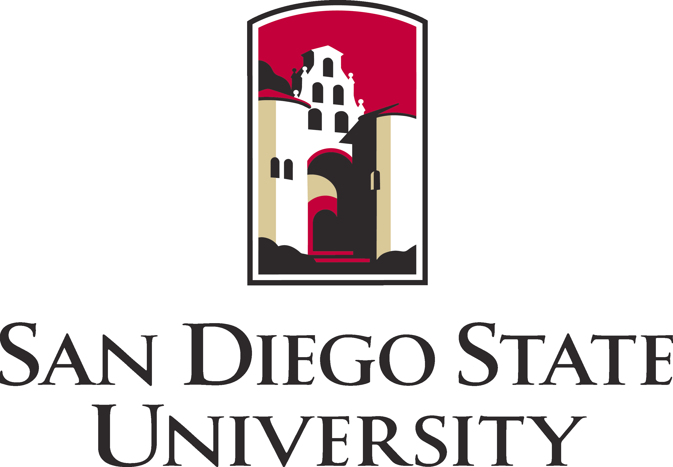

Rehabilitation Counseling Program
Department of Administration, Rehabilitation Counseling and
Postsecondary Education

San Diego State University
3590 Camino del Rio North
San Diego CA 92108
VOICE: 619  594  2462

FAX: 619  594  4208
TDD: 619  594  6406
http://www.interwork.sdsu.edu

Dear Potential Student:

Have you thought about returning to school for an advanced degree? Do you need financial aid? Are you interested in establishing a rewarding career in the helping professions? The Master of Science in Rehabilitation Counseling Program (RCP) at San Diego State University prepares professionals to provide responsive and effective services to individuals with physical, cognitive and psychiatric disabilities. Applicants must have a Bachelors degree, preferably in a human service-related area.

The RCP degree is versatile and prepares students to work directly with clients or in supervisory and administrative positions with the Department of Rehabilitation and the Department of Veterans Affairs as well as in nonprofit and for profit agencies, schools, colleges and universities, The RCP provides specialized instruction in the following areas:

- Specializations in cognitive disabilities, psychiatric rehabilitation and assistive technology;
- Coursework in program evaluation and development, and grant writing;
- Instruction on school to work transition, supported employment, neuropsychological and vocational assessment, and career counseling and development;
- Training in evidence based counseling methods such as Motivational Interviewing and Solution Focused Brief Therapy;
- Skill building in teamwork and collaboration;
- Strong emphasis on diversity and community inclusion of people with disabilities;
- Coursework and scheduling are designed to accommodate the needs of working adults:
- Extensive network with regional provider agencies.
- Preparation for the Certified Rehabilitation Counselor Credential.

Applications are now being accepted for the Rehabilitation Counseling Program for Fall 2013.
Applications require both a CSU Mentor and department application (i.e., Online Program Application) and applications are submitted online. To access the CSU

Mentor and Online Program Application forms, please go to: http://coe.sdsu.edu/admissions/applynow/
The deadline to register with CSU Mentor is March 1, 2013 (note: you have until April 1 to submit your transcripts and GRE scores to SDSU). The department application is due April 1, 2013.
Monthly stipends are available to qualified students. You can learn more about the Master of Science in Rehabilitation Counseling at http://interwork.sdsu.edu/main/rcp.

We will be hosting a Rehabilitation Counseling Open House on Friday, February 1, 2013 from 4 pm to 6 pm at the Interwork Institute. The Interwork Institute is located at 3590 Camino del Rio North, San Diego, CA. Parking is free and no RSVP is required. You will have a chance to meet the faculty and learn about their respective areas of expertise. We will also discuss program specializations, funding, courses, and the application process.

If you would like to meet with a faculty member to discuss the RCP, contact the Rehabilitation Counseling Program Coordinator, Charles Degeneffe, at cdegenef@mail.sdsu.edu or 619-594-6921. We look forward to hearing from you.

Sincerely,

Marjorie F. Olney, Ph.D., CRC, CPRP
Recruitment Committee Chair

Charles Edmund Degeneffe, Ph.D., CRC, ACSW
Program Coordinator
Rehabilitation Counseling Program

